
DECEMBER 3, 2025
7:00 p.m.

MIDWEEK ADVENT WORSHIP
Wednesday, December 3, 2025

IN THE NAME OF JESUS, WELCOME TO ST. PAUL'S!

VESPERS

7:00 p.m.

✠ ✠ ✠

PRELUDE Creator of the Stars of Night
Setting: Benjamin M Culli

ENTRANCE VERSE (Stand) LSB 229




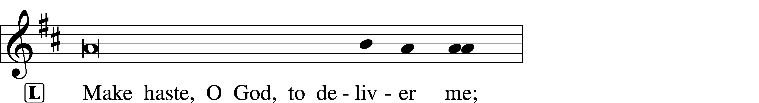
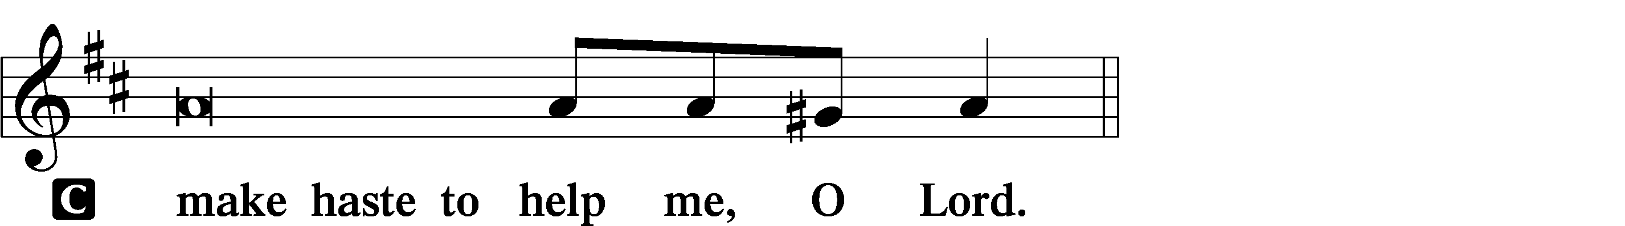

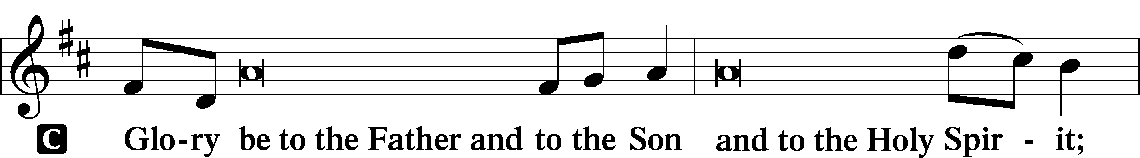
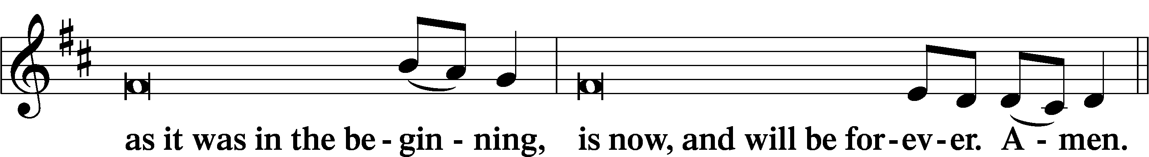
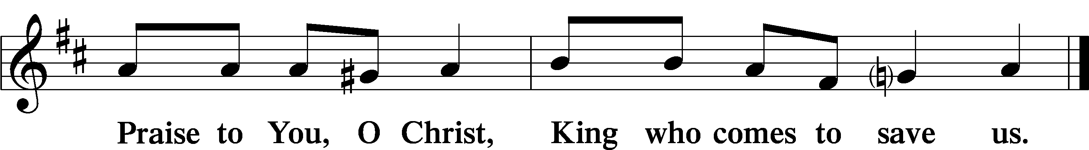
ADVENT HYMN Creator of the Stars of Night LSB 351

1 Creator of the stars of night,
Thy people’s everlasting Light:
O Christ, Redeemer, save us all
And hear Thy servants when they call.

2 Thou, grieving that the ancient curse
Should doom to death a universe,
Hast found the healing, full of grace,
To cure and save our ruined race.

3 Thou cam’st the Bridegroom of the bride,
As drew the world to eventide,
The spotless Victim all divine
Proceeding from a virgin shrine.

4 At whose dread name, majestic now,
All knees must bend, all hearts must bow;
All things celestial Thee shall own,
And things terrestrial, Lord alone.

5 O Thou, whose coming is with dread
To judge the living and the dead,
Preserve us from the ancient foe
While still we dwell on earth below.

D 6 To God the Father and the Son
And Holy Spirit, Three in One,
Praise, honor, might, and glory be
From age to age eternally. Amen.

FIRST READING (Be seated) Genesis 15:1-6

After these things the word of the Lord came to Abram in a vision: “Fear not, Abram, I am your shield; your reward shall be very great.” But Abram said, “O Lord God, what will you give me, for I continue childless, and the heir of my house is Eliezer of Damascus?” And Abram said, “Behold, you have given me no offspring, and a member of my household will be my heir.” And behold, the word of the Lord came to him: “This man shall not be your heir; your very own son shall be your heir.” And he brought him outside and said, “Look toward heaven, and number the stars, if you are able to number them.” Then he said to him, “So shall your offspring be.” And he believed the Lord, and he counted it to him as righteousness.

This is the Word of the Lord.
Thanks be to God.

RESPONSORY (Stand)

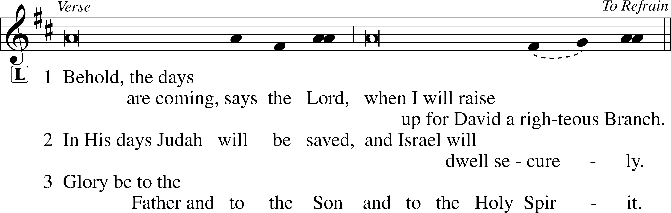
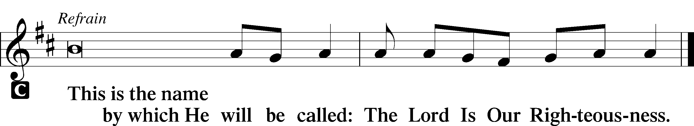

SECOND READING Matthew 1:1-17

The Holy Gospel according to St. Matthew, the 1st chapter
Glory to You, O Lord.

The book of the genealogy of Jesus Christ, the son of David, the son of Abraham.
Abraham was the father of Isaac, and Isaac the father of Jacob, and Jacob the father of Judah and his brothers, and Judah the father of Perez and Zerah by Tamar, and Perez the father of Hezron, and Hezron the father of Ram, and Ram the father of Amminadab, and Amminadab the father of Nahshon, and Nahshon the father of Salmon, and Salmon the father of Boaz by Rahab, and Boaz the father of Obed by Ruth, and Obed the father of Jesse, and Jesse the father of David the king.
And David was the father of Solomon by the wife of Uriah, and Solomon the father of Rehoboam, and Rehoboam the father of Abijah, and Abijah the father of Asaph, and Asaph the father of Jehoshaphat, and Jehoshaphat the father of Joram, and Joram the father of Uzziah, and Uzziah the father of Jotham, and Jotham the father of Ahaz, and Ahaz the father of Hezekiah, and Hezekiah the father of Manasseh, and Manasseh the father of Amos, and Amos the father of Josiah, and Josiah the father of Jechoniah and his brothers, at the time of the deportation to Babylon.
And after the deportation to Babylon: Jechoniah was the father of Shealtiel, and Shealtiel the father of Zerubbabel, and Zerubbabel the father of Abiud, and Abiud the father of Eliakim, and Eliakim the father of Azor, and Azor the father of Zadok, and Zadok the father of Achim, and Achim the father of Eliud, and Eliud the father of Eleazar, and Eleazar the father of Matthan, and Matthan the father of Jacob, and Jacob the father of Joseph the husband of Mary, of whom Jesus was born, who is called Christ.
So all the generations from Abraham to David were fourteen generations, and from David to the deportation to Babylon fourteen generations, and from the deportation to Babylon to the Christ fourteen generations.

This is the Gospel of the Lord.
Praise to You, O Christ

SERMON (Be seated)

Grace, mercy and peace to you from God our Father and from our Lord and Savior Jesus. Amen. Dear friends in Christ:
When you were a child, what did you cherish most about your family? Are there things that come quickly to mind?
As you aged, did you ever dig deeper into your family tree? If so, what did you find? Did anything surprise you? Probably so! That’s the way it is with most families.
I ask these questions because at some point in the hustle and bustle of the season, many of us will go back to our homes. And this home may not be a childhood place or any other place for that matter. “Home” first means family and family get-togethers—wherever those gatherings take place.
Family gatherings can be wonderful. But not always. And that’s because some family trees aren’t so “delightful.”
There might have been a point in your life where you stepped back from certainly family gatherings because of the non-delights. Maybe that’s still the case.
In the same way, maybe when doing your family research, you said to yourself: “Wow, my family tree is a mess!” Maybe you even said things like: “Our tree is a few branches short,” or “crazy really is a relative term here,” or “who knew I was so ancestrally challenged.”
A friend of mine recently probed into his family tree and told me that it revealed an unsettling share of shocks and surprises. He mentioned cohabitation, a shotgun wedding, children and grandchildren out of wedlock, depression, rebellion against parents, amputations, years of incarceration, substance abuse, marital desertion, an affair, suicide, physical and verbal abuse, time in a mental institution, and… my favorite… moonshining. The unsettling feeling came as his idealized family suddenly met his real family. And this then caused one word to rise up in his mind. That word is “dysfunction.”
Family disfunction often has traits, symptoms, problems, crises, and behavioral patterns that are passed down from generation to generation. Maybe some of you have discovered these as you’ve laid bare your own family tree. In fact, maybe you’ve had times when the light bulb turns on and you realize: “That’s why our family gatherings are so whacky.” Or you’ve discovered the cause of things such as those unwritten rules that every family has – rules such as ‘Don’t ask, don’t tell” or “Just smile, fake it and endure.’”
In our Gospel reading today, Matthew turns a family page, which is fitting because this page is the start of the whole New Testament. Matthew begins with a genealogy of Jesus—a glimpse at Jesus’ family tree. And while we might be tempted to skip over the long list of names – like we do with the credits of a movie – and get to the “good stuff” of the narrative, we shouldn’t do so, because Matthew’s opening genealogy is far from just a regurgitation of ancient, dry data. Rather, the genealogy that opens the New Testament proclaims God’s masterful providence over all salvation history and shows how it reaches its climax and fulfillment in one person: Jesus Christ, the son of David, the son of Abraham.
As we peer into Jesus’ genealogy, we see that this is not the kind of family tree we might expect. There are dirty details and embarrassing names here. Matthew has not glossed them over nor removed them from the list. You’ll see this as we highlight a few such branches in Jesus’ tree.
Verse 2 reads: “Abraham was the father of Isaac.” And here we note that an apple doesn’t fall far from the tree. For on two occasions, Abraham lied about the identity of his wife Sarah, claiming she was his sister. And decades later, when his own son Isaac travels to Gerar and the men there ask about his wife Rebekah, Isaac—like his father had done—lies by saying: “She is my sister.”
Verse 3 mentions “Judah, the father of Perez and Zerah by Tamar.” Theirs is a sordid tale for sure. Tamar had married Judah’s eldest son—Er. When Er does evil in God’s sight, God takes his life. In accordance with Jewish law, Judah then gives Tamar his second eldest son Onan; and Onan also does evil in God’s sight, so God takes his life too. Judah then refuses to give Tamar his third son. And like an episode right from a soap opera, in Judah’s shame, guilt and depression, he then has relations with a woman he thinks is a prostitute but who later turns out to be his own daughter in-law, Tamar, in disguise. Their one-night stand together results in twins— Perez and Zerah. As the saying goes, this episode contains “all kinds of wrong.”
As the genealogy progresses, verse 10 draws our attention to “Hezekiah the father of Manasseh, and Manasseh the father of Amos.” Hezekiah was generally a good king, but his son Manasseh turns out to be the evilest king in Judah’s history. Manasseh set up pagan places of worship and altars to Baal, then worshiped these hosts of the heavens and burned his sons as an offering. He also used fortune-telling, sorcery, witchcraft, wizards and placed a carved idol in God’s house. This relative was a piece of work for sure.
We haven’t even talked about the other, more well-known episodes in Matthew’s list, such as Jacob’s deception, Rahab’s harlotry, David’s immorality with the wife of Uriah, Solomon’s disloyal heart, Ahaz’s idolatry, or Hezekiah’s pride. All these show that it doesn’t take much digging to find the “sap” in Jesus’ family tree. There were lots of “sticky” situations for sure.
And why is there so much dysfunction in Jesus’ own tree, and in ours? The answer lies within the word dysfunction itself, which contains the letters S and I and N. Yes, dysfunction comes from sin. And the dysfunction builds as sin begets sin, generation after generation.
This begetting of sin, as we know, goes all the way back to our primal parents’ disobedience with the tree in God’s garden. Remember the story? Adam and Eve, despite God’s prohibition, ate the forbidden fruit from the tree of the knowledge of good and evil. And sin then entered our human story. Is there any wonder we all have such inglorious family trees?
Yet Matthew commences his gospel with his genealogy not to rub our noses in our collective shame but to proclaim God’s grace. He wants us to see that God – precisely at that moment – was grafting a completely new Branch into humanity’s fallen tree.
That branch is “Jesus…who is called Christ” (v 16). He is the son of Joseph and Mary and all those who came before him in the family God was using to bring his redemption.
A mere five verses after the genealogy concludes, an angel of the Lord explains the magnitude of what is happening to Joseph. While telling of his son – soon to be born and named Jesus – he explains: “He will save his people from their sins” (Matthew 1:21).
This Jesus would indeed go on to save us all from our sins. And not through charm, incantation or special craft as was the strategy of some of his relatives, but through the bloodying of a tree on Calvary – the tree of the cross.
Our salvation from sin and death has been made possible by this. Through our baptism into Jesus’ name, death and resurrection, the Holy Spirit has grafted us into his life-giving tree. Now when the Father looks upon us, he does not see the sap of our dysfunction and disobedience, but rather his perfect and righteous Son in our place.
This is grace! Beautiful and redemptive. And we celebrate its commencement in the birth of Jesus, our Savior.
What a perfectly redeemed and soon-to-be restored family tree! And what a forever family gathering his return will bring! We are blessed to be a part of it.
May God lead us to appreciate this always. Amen

MAGNIFICAT (Stand) My Soul Rejoices LSB 933

1 My soul rejoices,
My spirit voices—
Sing the greatness of the Lord!
For God my Savior
Has shown me favor—
Sing the greatness of the Lord!
With praise and blessing,
Join in confessing
God, who is solely
Mighty and holy—
O sing the greatness of God the Lord!
His mercy surely
Shall rest securely
On all who fear Him,
Love and revere Him—
O sing the greatness of God the Lord!

2 His arm now baring,
His strength declaring—
Sing the greatness of the Lord!
The proud He scatters,
Their rule He shatters—
Sing the greatness of the Lord!
Oppression halted;
The meek exalted.
Full are the hungry;
Empty, the wealthy—
O sing the greatness of God the Lord!
Here is the token
All that was spoken
To Abr’ham’s offspring
God is fulfilling—
O sing the greatness of God the Lord!

OFFERING (Be seated)
Offerings support the church’s mission work – both here and through our many partners. Offerings may be placed in the box at the sanctuary entrance or sent to the church through our website or the mail. Fellowship Cards help us welcome new people and track participation. Please fill one out and place it in the offering box following the service.

PRAYERS (Kneel) LSB 233-234

KYRIE LSB 233
Lord, have mercy;
Christ, have mercy;
Lord, have mercy.

LORD’S PRAYER

Our Father who art in heaven,
hallowed be Thy name,
Thy kingdom come,
Thy will be done on earth
as it is in heaven;
give us this day our daily bread;
and forgive us our trespasses
as we forgive those
who trespass against us;
and lead us not into temptation,
but deliver us from evil.
For Thine is the kingdom
and the power and the glory
forever and ever. Amen.

COLLECT FOR PEACE

O God, from whom come all holy desires, all good counsels, and all just works, give to us, Your servants, that peace which the world cannot give, that our hearts may be set to obey Your commandments and also that we, being defended from the fear of our enemies, may live in peace and quietness; through Jesus Christ, Your Son, our Lord, who lives and reigns with You and the Holy Spirit, one God, now and forever.
Amen.
LUTHER’S EVENING PRAYER Setting: John A. Behnke

Choir:
I thank you, my heav'nly Father,
through Jesus Christ, Your
dear Son, that You have kept me this day.
I pray that You forgive me
for all the wrong that I have done this day.
For into Your hands I commend myself,
my body and soul, and things.
Let Your holy angel be with me,
that the evil for may have no power over me.

Congregation and Choir:
I thank you, my heav'nly Father,
through Jesus Christ, Your dear Son,
that You have kept me this day.
I pray that You forgive me
for all the wrong that I have done this day.
For into Your hands I commend myself,
my body and soul, and things.
Let Your holy angel be with me,
that the evil for may have no power over me.
I thank you, my heav'nly Father
through Jesus Christ, Your dear Son,
that You have kept me this day,
I pray that you forgive me
for all the wrong that I have done this day.

Choir: Keep me this night. Amen

Those serving:

Greeter: Steve Berg
Reader: Janice Sebring
AV/Streaming: Richard Irwin
Acknowledgments
Unless otherwise indicated, Scripture quotations are from the ESV® Bible (The Holy Bible, English Standard Version®), copyright © 2001 by Crossway, a publishing ministry of Good News Publishers. Used by permission. All rights reserved. Created by Lutheran Service Builder © 2025 Concordia Publishing House.

351 Creator of the Stars of Night Text: Latin, c. 5th–10th cent.; tr. John Mason Neale, 1818–66, alt. Tune: Sarum plainsong, c. 9th cent., mode IV Text and tune: Public domain
290 Luther’s Evening Prayer Text: Martin Luther, 1483–1546; Luther’s Small Catechism, alt. Tune: John A. Behnke, b. 1953 Text: © 1986 Concordia Publishing House. Used by permission: OAR Hymn License no. 110005326 Tune: © 2018 Concordia Publishing House. Used by permission: OAR Hymn License no. 110005326

ADVENT & CHRISTMAS AT ST. PAUL’S

WORSHIP SCHEDULE


MIDWEEK ADVENT SERVICES
December 3, 10, 17 at 7:00 p.m.

******************************************************
Christmas Eve Worship – Wednesday, December 24

5:00 p.m. Candlelight service for families
7:30 p.m. Pre-service Music
8:00 p.m. Candlelight service with Holy Communion

Christmas Day Worship – Thursday, December 25

10:00 a.m. Celebration of Christ’s Birth
with Holy Communion

ST. PAUL’S LUTHERAN CHURCH
7426 IDYLWOOD ROAD
FALLS CHURCH, VIRGINIA 22043
A member congregation of the Lutheran Church–Missouri Synod

CONGREGATIONAL MINISTRIES
Leadership Officers, Working Boards, Chinese Ministry, The Preschool,
Sunday School, LWML, Youth Group, Altar Guild, Choirs,
Caring Ministry, Safety Ministry, Leisure Group
Other seasonal and occasional working groups

CHURCH STAFF
The Rev. Mark Shaltanis, Pastor
The Rev. Xinhong “Chris” Yang, Associate and Chinese Pastor
The. Rev. Wayne Lehrer, Pastor Emeritus

Kantor Aaron Jansen, Dir. of Parish Music Jill Cha, Preschool Director
Tawni Harrell, Director of Youth Norm Williams, Business Manager
Linda Fekete, Parish Secretary Richard Irwin, Building Manager

CONTACT US
Web site: www.stpaulsfallschurch.org
Office email: Secretary@stpaulsfallschurch.org
Business Manager email: businessmanager@stpaulsfallschurch.org
Pastor’s email: pastormark@stpaulsfallschurch.org
Safety Ministry: stpaulsafety@gmail.com
Office phone: 703-573-0295


For your giving convenience you can scan this QR code.

